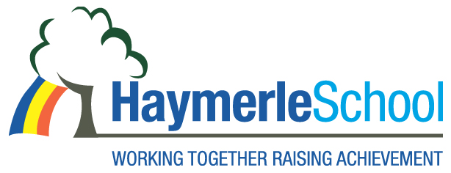
Office Administration Manager Vacancy

Haymerle Special School (Primary)

Salary: Hay Grade 7 (Scale 24-31) 36 hours per week, depending on experience.

Contract: Term Time Only

Term: Permanent

The Governors invites applications for the post of Office Manager. This is an exciting opportunity for a dynamic and enthusiastic candidate. Haymerle School is a primary Special School for pupils with Autism located in South East London (SE15 6SY). We support a wide range of learning disabilities including pupils with severe and complex social and communication difficulties. Haymerle School was judged a Good School in our March 2015 OFSTED inspection.

This is an opportunity for a candidate who:

• Strongly support our vision and ethos
• Has relevant qualifications at level 2 and beyond, as well as at least level 2 in English and Maths
• Has several years’ experience of working in an office environment and two or more years’ experience of managing school administration including management of staff
• Previous experience of dealing with school money and aspects of finance, as well as ordering, inputting invoices and managing school and office resources
• Has previous experience of managing and administering, pupil’s attendance and punctuality
• Is an effective manager of people, resources, information and systems
• Have excellent written and verbal communication skills
• Has experience of organisational effectiveness in previous positions
• Can lead and manage others but is also collegiate and an effective team player
• Is committed to continuous improvement of school administration and professional excellence
• Is committed to safeguarding children and are suitable to work with them
• Would be a positive and enthusiastic role model for our pupils

We are committed to safeguarding and promoting the welfare of children and young people and expect all staff and volunteers to share this commitment. All posts are subject to pre-employment checks, two references will be sought and successful candidates will need to undertake an enhanced Disclosure and Barring Services check (DBS), evidence of eligibility to work in the UK and evidence of qualifications.

Our recruitment processes follow the guidance in the DfE document Safeguarding Children and Safer Recruitment in Education.

All of the above checks must have been completed before the start of employment.
The post holder will be expected to carry out all duties in the context of and in compliance with the School’s Equal Opportunities Policies.

Please contact the School Office for an application pack on 020 7639 6080 or download on www.haymerle.southwark.sch.uk

Closing date for applications: Wednesday 25th April at 12:00

Interviews will be held on: Week commencing 21st May to 25th May 2018

Job Start: Summer 2018

Appointments will be made subject to satisfactory references.

