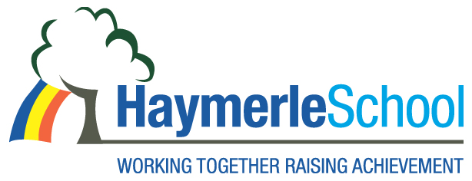
Special School Support Assistant Positions

Haymerle Special School (Primary)

Salary: Hay Grade 5 (Scale 16-23) 31hours per week, depending on experience.

Contract: Term Time Only

Term: Permanent

The Governors invites applications for the posts of Special School Support Assistants. This is an exciting opportunity for a dynamic and enthusiastic candidate.
About the School
Haymerle School is a primary Special School for pupils with Autism located in South East London (SE15 6SY). We support a wide range of learning disabilities including pupils with severe and complex social and communication difficulties. Haymerle School was judged a Good School in our March 2015 OFSTED inspection.
Our recruitment processes follow the guidance in the DfE document Safeguarding Children and Safer Recruitment in Education. All staff will be required to undertake a disclosure from the Disclosure & Barring Service.

The post holder will be expected to carry out all duties in the context of and in compliance with the School’s Equal Opportunities Policies.

Please contact the School Office for an application pack on 020 7639 6080 or download on www.haymerle.southwark.sch.uk

Closing date for applications: Friday, 24th November at 12:00

Interviews will be held on: Week starting on 27th November to 1st December

Job Start: 02 Jan 2018

Appointments will be made subject to satisfactory references.

