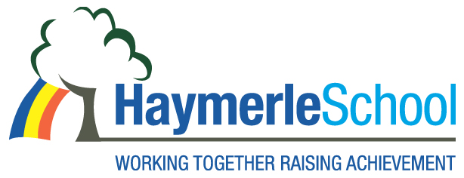

Special School Support Assistant Positions

Haymerle Special School (Primary)

Salary: Hay Grade 5 (Scale 16-23) 31hours per week, term time only.

Contract: Part time

Term: Permanent

The Governors invites applications for the posts of Special School Support Assistants. This is an exciting opportunity for a dynamic and enthusiastic candidate.
About the School
Haymerle School is a primary Special School for pupils with Autism located in South East London (SE15 6SY). We support a wide range of learning disabilities including pupils with severe and complex social and communication difficulties. Haymerle School was judged a Good School in our March 2015 OFSTED inspection.
Our recruitment processes follow the guidance in the DfE document Safeguarding Children and Safer Recruitment in Education. All staff will be required to undertake a disclosure from the Disclosure & Barring Service.

The post holder will be expected to carry out all duties in the context of and in compliance with the schools Equal Opportunities Policies.

Please contact the School Office for an application pack on 020 7639 6080. For further information including a job description and an application form, visit: www.haymerle.southwark.sch.uk

Closing date for applications: 04/02/2016

Interviews will be held on: 01/03/2016

Appointments will be made subject to satisfactory references.

