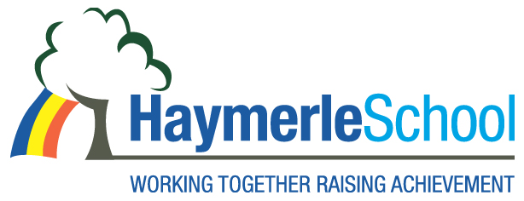

Special School Teaching Positions

Haymerle Special School (Primary)

Salary: Main Scale Inc. ILW + SEN Allowance (£2064)

Contract: Full Time

Term: Permanent

The Governors of Haymerle School are seeking to appoint hardworking and committed primary practitioners with experience and relevant training in working with pupils in a special needs setting (Autism).
Please note that NQTs are welcome to apply.

Candidates should have:

- Experience of and commitment to raising achievement in a school setting
- The ability to demonstrate outstanding practice differentiating plans, writing Individual Education Plans, liaising with supporting agencies and implementing additional support programs to meet pupils’ specific needs.
- Relevant training and/or experience relating to working with pupils with autism and communication disorders in specific PECS and TEACCH training.
- Experience of managing a support staff team

This is an exciting opportunity for a dynamic and enthusiastic candidate.

About the School
Haymerle School is a primary Special School for pupils with Autism located in South East London (SE15 6SY). We support a wide range of learning disabilities including pupils with severe and complex social and communication difficulties. Haymerle School was judged a Good School in our March 2015 OFSTED inspection.
Our recruitment processes follow the guidance in the DfE document Safeguarding Children and Safer Recruitment in Education. All staff will be required to undertake a disclosure from the Disclosure & Barring Service.

The post holder will be expected to carry out all duties in the context of and in compliance with the schools Equal Opportunities Policies.

Please contact the School Office for an application pack on 020 7639 6080 or download the forms on www.haymerle.southwark.sch.uk

Closing date for applications: 23/05/2016

Interviews will be held in the week commencing 20-24th June.

Post Start: September 2016

Appointments will be made subject to satisfactory references.

We very much welcome visits to the school by prospective candidates.
We will welcome prospective candidates to visit the School on Monday, 16/05/2016 at 15:30. Please call the School on 02076396080 to register your interest in attending.

