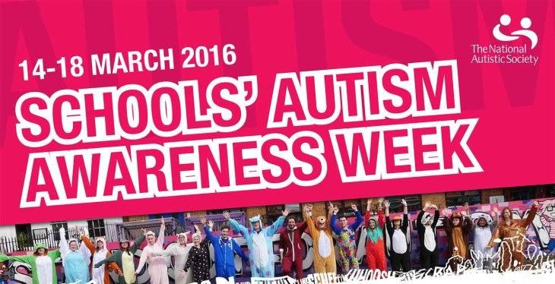

@ Haymerle School

**Dear All**

**Stand out for Autism!**

Friday 18 March

Make a £1 donation and wear something pink or purple to school. This is a great way of raising awareness! All proceeds will go to the National Autistic Society

**Coffee** **morning**

Monday 21 March

Family liaison officer Nancy welcomes parents for coffee and cake. Donations welcome

**Are you feeling lucky?** Take part in the sweepstake have some fun while raising money. See reception for details

**Resources to use at home**

The amazing song & Interactive storybook

<http://autism.sesamestreet.org/>