Communication and the use of Visual Support
A workshop for Parents and carers to make Picture Schedules.
The workshop will help you to:
- Think about your child’s communication level
- Make schedules to use at home
- Consider how communication supports behaviour

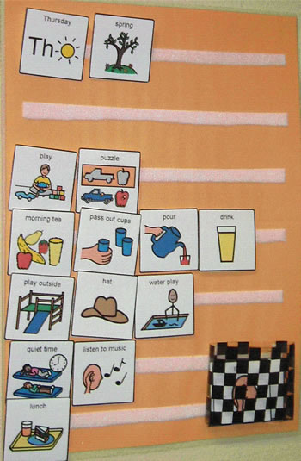

Parent Support Workshop at Haymerle School on
Thursday 3rd November 2016 from 10.00am-11:30am

With Diona Zheng (Educational Psychologist)

Please fill in the slip below to confirm you attendance or call the school office on 0207 639 6080 to book a place.

The course is open to all parents and carers interested in using Picture Schedule Strategies at home.

_____________________________________________________________________

Child’s name...............................................................................................

I will be attending the parent training session on Thursday 3rd November

Signature........................................................................................

