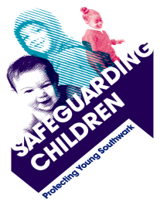



18th July 2017

**Re: Knife Crime and Young People**

Dear Parents and Carers,

We are writing to you to ask for your assistance in tackling the current increase in knife crime. You will be aware from the media coverage that London and the UK are suffering a worrying level of violence and in particular knife crime. Whilst this only directly affects a small proportion of people directly, one victim; is one victim too many. We know the impact stretches far beyond the victims and perpetrators, affecting many families and communities who want to feel safe to work, travel and live in Southwark.

**We would encourage you to think about raising this issue with your family. Some websites providing guidance and advice are listed at the end of this letter.**

**Facts**

* In the majority of cases the victims are young males
* Victims are often unwilling to engage as they do not wish to be seen to be speaking with the Police
* Victims and witnesses fear revenge attacks
* Research has shown that individuals carrying a knife are more likely to become a victim of crime
* We know that not all knife crime offences are linked to gang activity. From those young people working with us, it is clear some feel the need to carry knives for other reasons which may include protection, because of others carrying knives, peer pressure, or to feel they have respect, power or control

**What are we doing about this?**

* Partner agencies across Southwark are working together to support young people to have the skills to avoid the consequences of knife crime
* Parents and carers are encouraged to learn about the potential risks to their children and young people that knife carrying brings
* Knife carriers and known offenders are proactively targeted by the Police
* Weapon sweeps are carried out based on intelligence and information from the community
* Areas of concern in the community are prioritised for patrol
* Stop and search tactics are used to disrupt criminal activity
* Knives can be safely deposited in surrender bins to take them out of circulation

Yours sincerely,

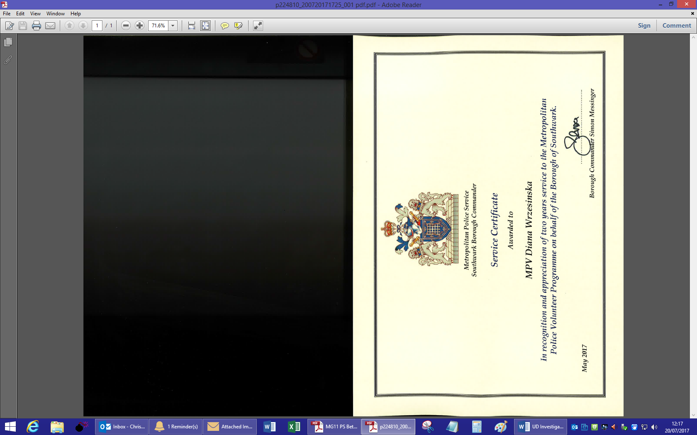

Simon Messinger - Detective Chief Superintendent

Southwark Police Borough Commander

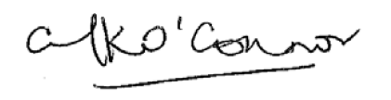

Michael O’Connor – Independent Chair

Southwark Safeguarding Children Board & Southwark Safeguarding Adults Board

**Information and Resources**

<http://noknivesbetterlives.com/>

It includes guidance about how to raise this issue and talk to your child.

You could also look at the Met website which provides further advice and guidance.

<https://www.met.police.uk/StopKnifeCrime>

If you need help or support in relation to concerns about your child or young person you can call Family Lives (formerly Parentline) on 08000 28 22 23 and make your child aware of the support available at Childline on 0800 1111.