[](http://www.haymerle.southwark.sch.uk/)

[](https://www.google.co.uk/url?sa=i&rct=j&q=&esrc=s&source=images&cd=&cad=rja&uact=8&ved=0ahUKEwjKyZuPnLjWAhUC0RQKHdzxAwcQjRwIBw&url=https://www.thechildmindingshop.co.uk/product/border-multicultural-disabled-children-welcome&psig=AFQjCNHbX2rtIMLjVCISIluMSbqykXkIqA&ust=1506149965942656)

I would like to take this opportunity to welcome back all of our children and to say a very big hello and welcome to our new children that have joined us this term! I’d like to also welcome Camelia – our new classroom teacher.

This new academic year is going to be full of opportunity and learning. In this newsletter, you’ll see that we have lots of things for parents and carers to get involved with and attend. We also have lots of great activities and events happening for the children this year.

You’ll also see in this newsletter, information relating to attendance, transport, term dates, clothing, safeguarding and other important information that maybe useful.

I’d like to wish everybody a fantastic Academic Year 2017/2018 and remind you that we are always striving to commit to our Mission Statement:

**‘Working Together Raising Achievement’.**

Many Thanks,

Liz Nolan

Headteacher

[](https://www.google.co.uk/url?sa=i&rct=j&q=&esrc=s&source=images&cd=&cad=rja&uact=8&ved=0ahUKEwjb0eOspLjWAhWBwxQKHaoUAWEQjRwIBw&url=http://www.alphat.org/category/bookkeeping/&psig=AFQjCNFsLj9mgZQP4GkQJLMuS_iKghUJiA&ust=1506151963787472)**If you would like anyone to talk to or you need some guidance or support, we are always here to help! We have regular coffee mornings were you get to mingle with other parents and support staff.**

**Also, we are always happy for you to give us a call to arrange a one to one meeting. Please call the school office on 020 7639 9906.**

[](https://www.google.co.uk/url?sa=i&rct=j&q=&esrc=s&source=images&cd=&cad=rja&uact=8&ved=0ahUKEwiHv7WOprjWAhVDXBQKHY7tDkYQjRwIBw&url=https://coffee.macmillan.org.uk/&psig=AFQjCNESmRtmcnSjyGGel3zH-EQ4e2oSLw&ust=1506152681191058)

Please come along to our first Coffee Morning of the academic year. You’re welcome to bring along a cake or biscuits (this is not compulsory). There’ll be a little tray for any spare change should you have any to spare that will be donated to MacMillan Cancer Support. However, if you don’t have any spare change, please still come along and join us.

[](https://www.google.co.uk/url?sa=i&rct=j&q=&esrc=s&source=images&cd=&cad=rja&uact=8&ved=0ahUKEwjAiNeItrjWAhUJzxQKHUzoBlMQjRwIBw&url=https://www.myips.org/attendanceawareness&psig=AFQjCNGBg2aPSRbBU61bn73lMP25PiRePg&ust=1506156942031853)

At Haymerle, we take attendance very seriously. We would like all of our pupils to have 100% attendance if possible. However, we also understand that some of our pupils may have appointments with other professionals – if this is the case, please inform the school as soon as possible, and bring a copy of the appointment letter so that we can authorise the absence.

If your child is ill, then please call the school office first thing in the morning. Please bring a doctor’s note if you have one. Should your child have persistent absences, then our EWO (Education Welfare Officer) from the Local Authority will be in contact with the parent/carer. It is a legal requirement for your child to attend school and no child will be authorised to have time off for holidays during term time. If your child’s attendance falls below 95%, this will be flagged up to our EWO.

Please work with us to ensure that your child has good or outstanding attendance. Many Thanks!

[](https://www.google.co.uk/url?sa=i&rct=j&q=&esrc=s&source=images&cd=&cad=rja&uact=8&ved=0ahUKEwiF1eaau7jWAhXEtRQKHavgAaIQjRwIBw&url=https://www.oakmanor.brent.sch.uk/brent/primary/oakmanor/site/pages/lettings/contactus&psig=AFQjCNEoKG_eEifEgnlP-wwv-jOcmY2lPQ&ust=1506158338511352)

**CONTACT DETAILS**

Please ensure that the school office has your most up to date contact details including postal address, home telephone number, mobile number and email (if you have one). There may be occasions when the school will need to reach you, for example, in the case that your child falls ill during the school day. It is imperative that we are able to contact someone at home in the event of an emergency.

[](https://www.google.co.uk/url?sa=i&rct=j&q=&esrc=s&source=images&cd=&cad=rja&uact=8&ved=0ahUKEwiCuYqJvLjWAhWLVhQKHdpWCHEQjRwIBw&url=http://metro.co.uk/2016/08/03/southwark-council-spends-over-15000-re-designing-its-logo-can-you-spot-the-difference-6046683/&psig=AFQjCNFakhHPciH4T_WvXC9Rv1XkN3mP-A&ust=1506158570640807)

**TRANSPORT**

We would like to inform those parents and carers whose children are brought to school and taken home on the school bus, that in the event that the school bus doesn’t turn up or is late in the morning, you must call Southwark Transport and not the school in the first instance. Southwark Transport isn’t the responsibility of the school office and so parents/carers should call:

**Southwark Transport Office: 020 7525 5209**

**Southwark Transport Mobile: 07932 373 381**

[](https://www.google.co.uk/url?sa=i&rct=j&q=&esrc=s&source=images&cd=&cad=rja&uact=8&ved=0ahUKEwijp6LPvrjWAhXIcRQKHUtbCQAQjRwIBw&url=http://www.cruiseminibuses.co.uk/&psig=AFQjCNEOcSHpYLMwT5BLdQ_wvio25M-4yw&ust=1506159257314051)You should only contact the school in the event that your child will either be late or will be absent. Should your child miss the bus, an arrangement should be made for the child to be brought in otherwise this will be an unauthorised absence.

[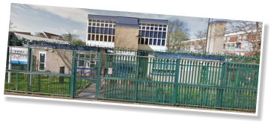](https://www.google.co.uk/url?sa=i&rct=j&q=&esrc=s&source=images&cd=&cad=rja&uact=8&ved=0ahUKEwjmjaGJv7jWAhUKuxQKHdFHCmAQjRwIBw&url=http://aeelkins.co.uk/education/&psig=AFQjCNHFfsdQQqeqYuLw-dhm2MidwDA0WA&ust=1506159323091973)

**DROPPING OFF AND PICKING UP**

Parents that drop off and pick up their children from school are asked to park their car in an appropriate place. We understand that parking can be difficult, but please do not park on the Zig Zag lines directly in front of the school as this obstructs others from crossing the road safely and also stops the school busses from accessing their pick up points. Also, be mindful when leaving siblings in the car on their own whilst you run your child into school – we strongly discourage this.

**[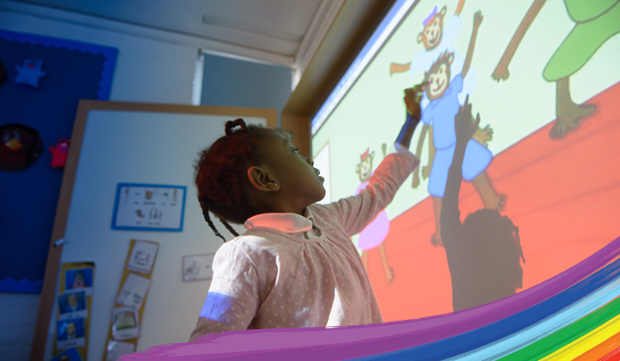](https://www.google.co.uk/url?sa=i&rct=j&q=&esrc=s&source=images&cd=&cad=rja&uact=8&ved=0ahUKEwiV04auwLjWAhWCORQKHXHTC58QjRwIBw&url=http://www.haymerle.southwark.sch.uk/&psig=AFQjCNHFfsdQQqeqYuLw-dhm2MidwDA0WA&ust=1506159323091973)SCHOOL UNIFORM**

Uniform is not compulsory at our school. However, we do recommend grey trousers or skirts, white or light blue polo neck t shirt, sensible robust shoes or trainers.

Many children benefit from the routine of wearing a school uniform and may reduce anxiety of having to choose what to wear every day. It can also provide a visual prompt for the child – indicating they are going to school.

[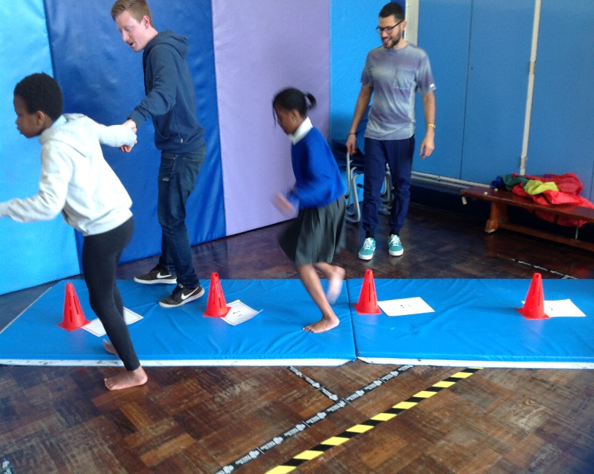](https://www.google.co.uk/url?sa=i&rct=j&q=&esrc=s&source=images&cd=&cad=rja&uact=8&ved=0ahUKEwjep_XLwbjWAhXLtRQKHfQ_DwAQjRwIBw&url=http://www.haymerle.southwark.sch.uk/pe-and-sport-grant-2/&psig=AFQjCNHFfsdQQqeqYuLw-dhm2MidwDA0WA&ust=1506159323091973)**PE KITS**

Children must change for PE and so please ensure they have a T Shirt and Shorts. Also, you will be informed if your child has swimming, so please ensure your child brings their swimming kit should they need it.

[](https://www.google.co.uk/url?sa=i&rct=j&q=&esrc=s&source=images&cd=&cad=rja&uact=8&ved=0ahUKEwiOsuu9wrjWAhVFuRQKHVmPAmwQjRwIBw&url=http://www.safechilduk.info/Charity/charity-safeguarding-home.html&psig=AFQjCNEIM-IQBMowklSAKADB-D02Nv2qTA&ust=1506160293654078)

**SAFEGUARDING AT HAYMERLE**

We have clear policies in place to ensure that staff and visitors understand the importance of safeguarding. Policies are in line with National Guidance and Southwark Guidance.

Parents and carers should be aware that if we have concerns regarding a child’s wellbeing or safety, we have a duty to raise these with you and/or the appropriate authorities as needed.

We will always work with parents and carers in carrying out this duty of care.

[](https://www.google.co.uk/url?sa=i&rct=j&q=&esrc=s&source=images&cd=&cad=rja&uact=8&ved=0ahUKEwiVufHpw7jWAhUEVxQKHTPVDVYQjRwIBw&url=http://autismchaostocalm.com/nonverbal-autism-and-tagteach-how-do-kids-know-what-they-did-to-earn-a-tag-if-you-cant-tell-them/questions-talk-bubble/&psig=AFQjCNFi0QW6V_uC7j8HsYYch_5_attodw&ust=1506160646680871)

**SPEECH BUBBLE**

[](https://www.google.co.uk/url?sa=i&rct=j&q=&esrc=s&source=images&cd=&cad=rja&uact=8&ved=0ahUKEwj65LaIxrjWAhWDvRQKHdrFD7sQjRwIBw&url=https://blog.oup.com/2016/02/music-therapy-and-arts-based-research/&psig=AFQjCNF3IG_CkOBsQywO7jkon9bv-LsCLQ&ust=1506161252809465)Speech Bubble are working in partnership again with Haymerle School staff to assist with children’s learning of speaking, listening and phonics.

**MUSIC THERAPY**

We are excited to welcome back Sarah – our music therapist this term who will continue to extend the skills and practise in sensory strategies. Sarah will work in collaboration with class teachers and parents.

**EDUCATION, HEALTH & CARE PLANS**

At some point this academic year, you will be invited to attend an ECHP meeting and/or Annual Review meeting. These are so important as they track your child’s progress and to see if your child is receiving the level of support needed. Letters and phone calls will go out accordingly.

[](https://www.google.co.uk/url?sa=i&rct=j&q=&esrc=s&source=images&cd=&cad=rja&uact=8&ved=0ahUKEwiK_oL42bjWAhVItRQKHYBYAwsQjRwIBw&url=http://fp2barazablog16-17.blogspot.com/2017/06/baraza-blog-18th-june-2017.html&psig=AFQjCNGmFrBOmdughP2amaFHX9ddrMNgAg&ust=1506166589448480)

**READING AREA**

At Haymerle, we love to read books. In the front reception area at school, we have a Book Corner where children are encouraged to take a book and read it. Please, if you have any unwanted books at home, please exchange it for a new book in our Book Corner.

[](https://www.google.co.uk/url?sa=i&rct=j&q=&esrc=s&source=images&cd=&cad=rja&uact=8&ved=0ahUKEwitqdOu2bjWAhVEbBoKHT_pDlMQjRwIBw&url=https://www.tes.com/jobs/employer/haymerle-school-1050767&psig=AFQjCNFyRek0RRcX84fYPNnUCYC7Q3Ai8A&ust=1506166174927779)**SCHOOL WEBSITE**

To keep updated with what’s going on in school, please visit our website regularly at:

**www.haymerle.southwark.sch.uk**

[](https://www.google.co.uk/url?sa=i&rct=j&q=&esrc=s&source=images&cd=&cad=rja&uact=8&ved=0ahUKEwj5pJb12rjWAhWBnRoKHejuBjYQjRwIBw&url=http://pedevents.co.uk/contact-us/&psig=AFQjCNGyD1h5OyX3gnPkI5Afpd7MT6aLww&ust=1506166845771646)

To contact us at school, call:

**020 7639 6080**

Or email:

**reception@haymerle.southwark.sch.uk**

[](https://www.google.co.uk/url?sa=i&rct=j&q=&esrc=s&source=images&cd=&cad=rja&uact=8&ved=0ahUKEwj_5uz527jWAhUC7xQKHbBgB_sQjRwIBw&url=http://www.barnett-wood.surrey.sch.uk/index.php?section%3D25%26page%3D333&psig=AFQjCNGitB-2Nj7tYrkWfsLOCruEpx6Z8g&ust=1506167104708171)**PARENT TRAINING AND COFFEE MORNING**

We provide many opportunities for parents to further their knowledge and to develop their skills. Please see the ones that we have already put in the diary, however, there will be others of which you’ll be informed in due course.

**FRIDAY 29th SEPTEMBER | 10am – 11am**

MacMillan Coffee Morning

**WEDNESDAY 4th OCTOBER | 10am – 11am**

OT (Occupation Therapy) Training - New Parents

**FRIDAY 13th OCTOBER | | 10am – 11am**

SALT Training - New Parents

**FRIDAY 20th OCTOBER | 10am – 11am**

Everyone Welcome for tea, coffee and biscuits.

**WEDNESDAY 8th NOVEMBER | 10am – 11am**

EP Training – All Parents Welcome

**FRIDAY 17th NOVEMBER | 10am – 11am**

SALT Training 2 - New Parents

**FRIDAY 24th NOVEMBER | 10am – 11am**

Everyone Welcome for tea, coffee and biscuits.

**TUESDAY 28th NOVEMBER | 10am – 11am**

Safeguarding Training – All Parents Welcome

**FRIDAY 1st DECEMBER | 10am – 11am**

Healthy Eating – New Parents

**FRIDAY 15th DECEMBER| 10am – 11am**

Everyone Welcome for tea, coffee and biscuits.

[](https://www.google.co.uk/url?sa=i&rct=j&q=&esrc=s&source=images&cd=&cad=rja&uact=8&ved=0ahUKEwjw5-3CyrjWAhXHvRoKHeAdCEsQjRwIBw&url=http://www.steps-aba.it/post/services/parent-training&psig=AFQjCNG5hS3JXqPgkEfELdl6du266vePfQ&ust=1506162449550629)New Starter Parents – please do your best to attend the events specially arranged for you. These will provide invaluable knowledge and skills.

We encourage all parents and carers to support these events as much as possible, helping us to follow our Mission Statement: ‘Working Together Raising Achievement’.

**TERM DATES FOR YOUR DIARY**

**Academic Year 2017/18**

**Autumn term**

Wednesday 6 September to Friday 20 October

Half term: Monday 23 October to Friday 27 October

INSET DAY (School Closed): Monday 30October

Tuesday 31 October to Wednesday 20 December

**Spring term**

Tuesday 2 January to Friday 9 February

Half term: Monday 12 February to Friday 16 February

Monday 19 February to Thursday 29 March

**Summer term**

Monday 16 April to Friday 25 May

Half term: Monday 28 May to Friday 1 June

Monday 4 June to Friday 20 July

**Public holidays**

Christmas Day - Monday 25 December 2017

Boxing Day - Tuesday 26 December 2017

New Year’s Day - Monday 1 January 2018

Good Friday - Friday 30 March 2018

Easter Monday - Monday 2 April 2018

May Day Bank Holiday - Monday 7 May 2018

Spring Bank Holiday - Monday 28 May 2018

Summer Bank Holiday - Monday 27 August 2018

*\*Please note that we have a further two INSET days to organise but we will inform everybody when these dates are announced. Haymerle School is also used as a Polling Station should there be any further Polling Days. Finally, in the event of bad weather, a notice will be placed on our website. For further information, please call 020 7639 6080.*