STRATEGIES TO HELP A CHILD WHO FINDS MAKING CHOICES AND COPING WITH CHANGES DIFFICULT

Use objects of reference
An object of reference is as the name implies an object, which has a particular meaning associated with it. For example spoon may be the object of reference for lunch. Alongside all the other signals regarding an event, the multi- sensory approach of an object of reference is likely to be more meaningful to a child rather than a verbal explanation of a visual picture or symbol.

At an intentional stage of communication, objects of reference can be used :-

- To inform a child what is going to happen
- Enable a child to make a choice
- Promote the understanding if a frequency of events

How to use an object of reference calendar system in the classroom:

- Objects calendars can be used to help facilitate communication.
- Help children transition from one activity to another.
- The team choses a few activities that the child choses on a daily basis
- They can then chose an object from each activity to represent that activity
- The object used to represent an activity needs to be meaningful to the child.
- You can work on joint attention, social interactions, anticipation, sequencing, object, exploration, choice making, turn taking.

- There are many different types of calendar systems you can use with a student

- Chose a few fun activities that the student does on a daily basis.

- Chose an object from each activity to represent the activity.

- The object needs to be meaningful to the child and needs to be used during the activity.

- Cue the child that an activity is about to occur by presenting the object associated with that activity.

- Allow the child to handle the object and explore as child wishes

- Immediately take the child to the area where the activity is going to occur. Cue the child that the activity to finished by presenting a distinctive basket that is unlike any other basket of his/ her daily routine. This is the ‘finished basket’

- At least once a day, present a different activity to the child and let the child explore. When the child picks up one object and begins to play with it, go do that activity with that child.

Once the child understands the meaning if a few objects of reference, they can be shows to the child. These can be used to help the child made a choice. E.g. they can reach for once instead of looking at one or the other. (this will only be possible once the child knows the purpose/ use of these objects)

Bridging the gap between objects of reference and symbols:-

For some children with complex needs, the may find it more difficult to understand what photographs, pictures or symbols represent.
Objects of reference can help fill this gap. Having an object of reference stuck to the picture symbol can do this. This will aid the child form a stronger representation of the object and associate it with the picture. For example in the picture below, the object of reference ‘spoon’ is associated with the technology room. It is supported with a symbol of the spoon.

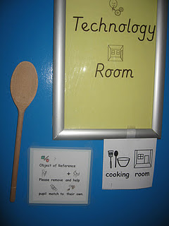

Now and next board
Now and Next Board (sometimes referred to as ‘First and Then’)

What is a ‘Now and Next’ board?
The board has the words ‘Now’ on the left-hand side and ‘Next’ on the right-hand side with a space underneath to add a symbol or photograph. It could be described as a miniature version of a visual timetable and helps a child to move on from one activity to another.

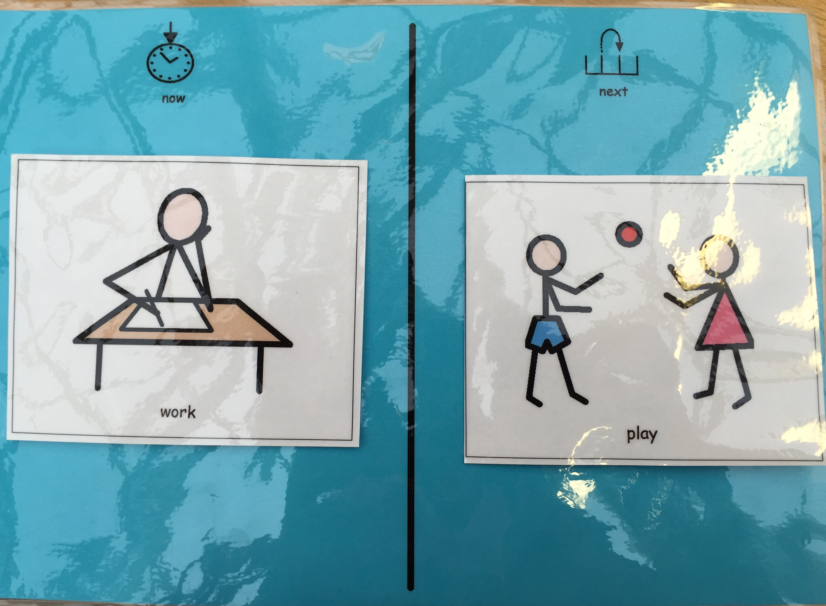

Who might benefit from a ‘Now and Next’ board?
- A child who has difficulty finishing one activity and starting another.
- A child who is reluctant to participate in a particular activity, for example messy play (in this case the second item on the board would be something which you know the child really enjoys)
- A child with limited attention skills.

How does it work?
Place a symbol on each side of the board. It’s a good idea to place an activity that really motivates the child on the ‘Next’ side of the board. This acts as a ‘reward’, something for the child to aim for.

Show the child the board, point to each symbol individually and support the child by saying, “cutting now….cars next”. It is important to reduce language by using key words only.

When the child has engaged with the gluing activity for some time the adult should inform the child by saying “gluing finished... now cars” whilst pointing to the next symbol.

Encourage the child to move on by supporting them to “post” the now symbol into a box or turning it over before moving onto the next activity

Haymerle SLT team

