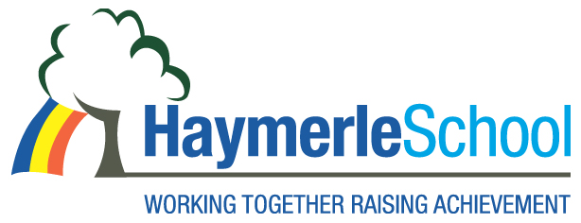
Our Mission
Haymerle School is a safe learning environment where everyone

- has high expectations and celebrates achievement
- can develop lifelong learning skills
- respects themselves, each other and the world around them

