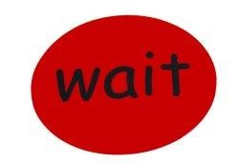

**How to use ‘WAIT’ cards**

**WHY:**

These cards are to help your child learn to wait for objects he wants. They will help him understand that “**wait”** does not mean “NO” but that it means “later”. He will get what he requested *eventually*.

**WHERE:**

Is there a suitable place at home/ in the classroom where you can always put the item until you are ready to give it to him? This will help reinforce your child’s understanding that if items go in that particular place; it means he will get it eventually. If not, then find somewhere that is out of reach

**HOW:**

These cards are to be used in exchange for the item(s) that your child wants.

When your child requests something they want, give them the red

‘wait’ card to hold and put it in your special ‘waiting area’. Help your child to wait 10 seconds initially and then give them the item in exchange for the ‘wait’ card. Praise them for “good waiting”.

As your child begins to understand what the ‘wait’ card means, you will be able to gradually increase how long he has to wait for it.

The waiting can be supported by the use of a sand-timer, so your child can actually see how long they have to actually wait for.

USING TOKENS:

You can use the ‘wait’ cards to encourage your child to complete specific activities. If your child has requested a specific item, you can tell them they need to wait and complete initially one activity. Use the ‘wait’ card which has a token space. When the child has finished the activity, they get a token, which they can put on the ‘wait’ card. They can now exchange the ‘wait’ card for their desired item.