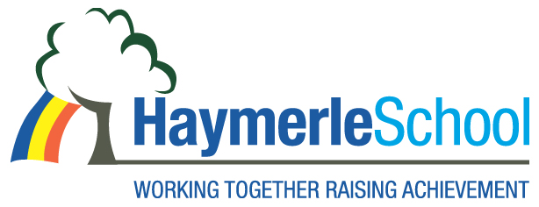

Job Context

Haymerle School supports pupils with a diagnosis of Autism (Foundation Stage to Key Stage 2). We currently support pupils with severe and complex learning disabilities, social and communication disorders. The majority of pupils have speech and language difficulties and learning disabilities.

We use Picture Exchange Communication to facilitate communication for our pupils across the school and use TEACCH to support the school day and curriculum delivery.

We are located in Peckham in South East London an area that has benefited recently from large scale regeneration and investment in housing and leisure facilities including the Peckham Pulse Leisure Centre and the New Library.

The school is in a 1960’s building which has been extensively renovated and the grounds landscaped.

Our current pupil population is 75 and made up from pupils from Southwark and neighbouring boroughs Lewisham and Lambeth. Class sizes vary depending on the needs of the pupils (up to 7 pupils).

For more information on what we do, please visit the School’s website on www.haymerle.southwark.sch.uk

