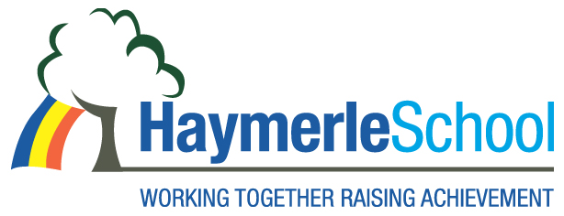

School Business Manager Vacancy

Haymerle Special School (Primary)

Salary: Hay Grade 10 (£40,503 - £47,736)

Contract: Full Time Term: Permanent

Haymerle School is a primary Special School for pupils with Autism located in South East London (SE15 6SY). We support a wide range of learning disabilities including pupils with severe and complex social and communication difficulties. Haymerle School was judged a Good School in our December 2021 OFSTED inspection.

We are pleased to offer this exciting opportunity for a motivated and forward-thinking Business Manager who will take responsibility for the school’s financial strategy, Site Management, Human Resource and Administrative functions, supported by our strong, dedicated Admin Team. The successful candidate will need commitment, drive, flexibility and ambition to support the school in its future development and this is a perfect opportunity to develop your career if you have the necessary drive and passion.

We are interested in someone –

- With a relevant professional qualification or degree level academic achievement;
- With experience in financial management including setting budgets;
- Who is highly organized and good at prioritizing
- With experience of Human Resources
- With experience of Facilities Management
- With experience of RM Finance or RM Unify/RM Integris (MIS database)

In return we can offer:

• A friendly and supportive working environment
• A commitment to opportunities for your professional development

As a School, we strive to create a safe and secure environment with Safeguarding at the heart of what we do. As part of the Management Team, you will play a vital role in maintaining a safe and secure environment.

As part of Southwark’s commitment to safeguarding and promoting the welfare of children and young people, all employees employed within schools are required to undergo an enhanced DBS check.

The post holder will be expected to carry out all duties in the context of and in compliance with the schools Equal Opportunities Policies.

Please contact the School Office for an application pack on
020 7639 6080 or download the forms on www.haymerle.southwark.sch.uk

Closing date for applications: 12:00 noon 6th March 2023
Interviews will be held on: Week commencing 20th March 2023
Post Start: As soon as possible.

Appointments will be made subject to satisfactory references.

We very much welcome visits to the school by prospective candidates. Please call the office on 0207 639 6080 if you wish to arrange a visit.

